Seine Net Fishing

Definition
Seine fishing is a method of fishing that employs a surrounding net, called a seine, that hangs vertically in the water with its bottom edge held down by weights and its top edge buoyed by floats. Seine nets can be deployed from the shore as a beach seine, or from a boat.

As a Mancunian born in a suburb of Manchester, all I knew about fishing was putting maggots on a hook and casting it into a canal and wait for a fish to bite.

Then we came to St Dogmaels and discovered the truth about fishing. Initially from buying fresh fish from Mandy at the weekly market. Then speaking to Len and seeing him going out in his boat. Then heard about this Seine Net fishing.

So I looked for a definition and found this on the web.

I also discovered there are in fact a number of different versions of it.

Types 1
Beach seine
The beach seine is employed by anchoring a section of netting on the shoreline, then dragging the net into the water and surrounding the fish, before pulling it ashore.

Image:
Fishermen horse seining for salmon on the Columbia River, n.d
John Nathan Cobb (1868–1930)

This is in Canada and employs horses to help bring the net in with all its contents. But essentially it was what is carried out here.
Types 2
Purse seine
A common type of seine is a purse seine, named such because along the bottom are a number of rings. A line (referred to as a purse-line) passes through all the rings, and when pulled, draws the rings close to one another, preventing the fish from "sounding", or swimming down to escape the net.

Image:
Purse seining boat, location unknown, n.d.
John Nathan Cobb (1868–1930)

This is a variation on beach as it has a way of closing the bottom of the net. It can be used from the beach as well. This is used world wide and with larger boats.
Types 3
Power block
The power block is a mechanized pulley used on some seiners to haul in the nets.

Images:
Hauling net with power block on salmon purse seiner 2012? Othe photo close up of the pulley

According to the UN Food and Agriculture Organization, no single invention has contributed more to the effectiveness of purse seine net hauling than the power block.

Types 3
Drum
The drum seine uses a horizontally mounted drum to haul and store the net instead of a power block. The net is pulled in over a roller, which spans the stern, and then passes through a spooling gear with upright rollers. The spooling gear is moved from side to side across the stern which allows the net to be guided and wound tightly on the drum.

Salmon seiner drumming in the net. Note seine skiff holding vessel off the net. 1967

Again this used widely.

Types 4
Danish seine
A Danish seine, also occasionally called an anchor seine, consists of a conical net with two long wings with a bag where the fish collect. Drag lines extend from the wings and are long so they can surround an area. The seine boat drags the net in a circle around the fish. The motion of the warps herds the fish into the central net.

The Philippine government bans the use of Danish Seine and Modified Danish Seine in its waters due to their destructive impact on marine habitats and fishery resources, imposing imprisonment and fines for violators.

St Dogmaels Seine Net Fishing
Film
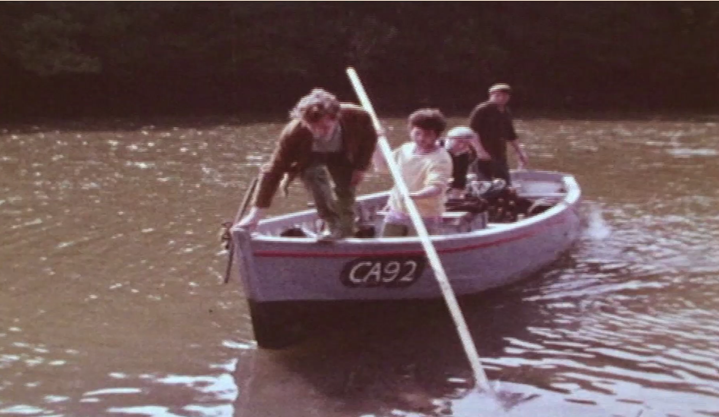

So here we have the local fisherman using the Seine nets to catch salmon with a boat

Needless so say the there is a long history of Seine Net Fishing
History =- 1
The oldest known net, dating back to 8300 BC, was found in the ancient city of Andréa, Finland (now Kaemennogorsk, Russia).
12th Century - When monks arrived at St. Dogmaels early in the twelfth century their first Abbot Fulchard, seeing the vast salmon stocks in the river introduced the 'seine' net from France.
In 1188 Giraldus Cambrensis, on his tour of Wales seeking recruits for the Crusades wrote, 'The River Teifi is a noble river that abounds more than any river in Wales with the finest salmon.’
George Owen recorded in 1603 that 'the Teifi salmon is far superior in quality and flavour to any other species in the country. There is an abundant supply, and the method of catching is seine netting.'
By the 1840's the river was running close to the Pembrokeshire side from the Glan Teifi to Pwll Cam and we are told that it was so full of salmon that it was a fisherman's paradise. This situation continued until the end of the 1850's when concern was first shown about fish stocks due to the deterioration of the condition of the river.
By the 1860's it became necessary to introduce a Fishery Act which stipulated that licences had to be taken out in order to fish in the river. The price of the licence was one guinea for a coracle or net. This provoked deep resentment amongst the fishing community.
Nevertheless in 1861 there were 42 seine netters, sixteen of the boats fishing from
St. Dogmaels. At this time the boats were crewed by seven men using local boats often built at Y Pinog. They were usually twenty five feet long, clinker built and painted with black tar. They were propelled by curved oars which were pushed through holes in the side of the boat and sometimes they carried a simple lateen sail. The nets used were 200 yards long and up to 12 feet deep with a 4 inch mesh. There was also 'y shot fawr’ where two nets were used together and placed across the neck of the estuary. Catches from this were enormous, regularly being between 140 and 170 salmon on each tide.
Because of he system of licences it was possible to know something about recorded
catches. Between 1860 and 61 the cardigan and Tivyside advertiser reported
enormous catches by the St. Dogmaels boats. In 1871 300 salmon were caught on one tide with the selling price being between threepence and sixpence a pound. In 1867 a group of St. Dogmaels men were sent to prison for fishing without licences and it is recorded that twenty boats caught 85 salmon on one evening and that the catch on the following tide weighed eight hundredweight.

History - 2
By 1886 a new Fishing Act fixed a close season of 154 days from September 1 until
February I.. This meant that the St. Dogmaels boats paid heavily for their licence
because the cold water limited them to four of the seven months. It was often too cold for them to start much before the end of April. They petitioned about this and
eventually it was agreed for them to fish in September in return for forfeiting
February and March.
The fishing itself traditionally started on the first tide following noon on Mondays and
finished on Saturday at noon. No fishing took place on Sundays. The pools fished
were Pwll y sgrefach, Pwll y Brig, Rhigyn web., Pwll Nhwicyn, Pw-11 cranc,Pwll cam
but the silting up of the river meant that some of these disappeared.
To decide the order of fishing at Pwll Castell lots were drawn using six numbered
stones. This was done on the first day of the season and established the pattern of who fished where and on what day.
The `ergyd', (cast), was always carried out from the starboard side of the boat. The
boat was taken in a semi-circle across the river, the bowman noting the depth with a
pole. The 'cap-ten' would steer with a crewman casting the net. The least experienced crew would be on the shore and would take care of the headrope. After the net was cast the boat was steered for the shore, all this would take about fifteen minutes. The crew would then take each side of the net and steadily haul it in folding the bottom of the net inside thereby making a bag or purse.
The number of boats had dropped to twenty by the mid 1920's. At the beginning of
the Second World War there were thirteen crews on the river and the crew numbers
had dropped from seven to five. Engines had begun to be used in boats by the mid
thirties often using an old Austin seven engine. (The remains of one of these can still
be found rusting on the shore near the Glan Teifi.)
By 1970 there were three or four boats each manned by a\crew of three or four.
In 1999 one boat was fishing. After nearly nine hundred years it would seem strange
to view the Teifi on a summer evening tide\without the sight of a san-boat at work or
at rest.
Sources
The History of St.Dogmaels Abbey Prichard
Gateway to Wales William Lewis
Tivyside 'Those were the Days' Donald Davies
Geoffrey Asson, Sincerity, St.Dogmaels
Image:

ca 1938 - Postcard of steamer 'Ben Rein' passing the Graig
SÂN (Seine) Salmon fishing at St. Dogmaels
I would like to read a piece written by a local fisherman, Eilir Phillips, who describes his experience of seine net fishing:
I was a member of the crew of a fishing boat around 1941.
No. of boats at the time around 10, all anchored at Cei Bade (boat quay)
below Graig footpath by the Tivy Inn, all powered by small petrol engines.
The river was divided into lots and numbers were drawn from a bag outside
the Tivy Inn to show where on the river a boat would fish next day.
Fish caught were brought to the Tivy Inn, weighed, labelled and left for the
dealer to collect, Harper from Cardigan, who would send the fish to
Billingsgate London. Later a local man, Washington Thomas started as a dealer.
No fishing on a Saturday or Sunday so the seine nets were hauled up to dry on
the Netpool outside the Tivy Inn. Money was paid by the dealer to the skipper
of the boat. He and the crew met at a local inn Tivy Inn, Ferry Inn, White Hart
Inn, Treffynon Inn, and shared the money. Each boat had four crew members,
the money shares was five, the owner of the boat receiving two shares.
In 1941 I fished on the boat Bonita owned by Tom Lewis David Street, crew
were Tom Lewis, Eilir Phillips, Jack Thomas, Brussel Griffiths.
On returning from the army I fished on the boats in 1948 and 1949, 1948 being
a good year and 1949 a bad year, very little fish.
Boat John was owned by Benjamen Richards, Union Terrace.
Crew, Benjamen Richards, Evan Jones, Eilir Phillips and Sidney Thomas.
On occasions the nets were treated with preservative, a boiler was lit outside
the Tivy Inn and the nets immersed and hung up to dry.
The fishing was carried out by one man with one end of the net standing on
the shore with the boat encircling the area and landing with the other end,
then both ends were hauled in and the salmon stunned with a wooden
truncheon.
In fine weather the boats would venture outside the estuary.
The deep pools on the river were called , pwll y Castell, pwll Nawpus, pwll Nantywerig, pwll Sano.
Article by Mr. Eilir Phillips.
LLECHWEDD, CWMINS, ST. DOGMAELS.

Enwau Pyllaul
Film
Mention of pool names but not found on maps
School children’s project created model with pool names

Dewis Pwll
Film
Choosing pool by picking a numbered stone for tomorrow

Washing & Weighing Fish
Film

Seine Nets
Mending nets

Image: Ca 1990 - Seine Net near Union Terrace, St Dogmaels - Harold Ray, Andrew Grota, Cyril Burton & Derek Burton (c) Stuart Ladd (Cyril Burton Collection)

Drying
Ca 1990 - Seine Net near Union Terrace, St Dogmaels - Harold Ray, Andrew Grota, Cyril Burton & Derek Burton (c) Stuart Ladd (Cyril Burton Collection)
The village green was once filled with over 200 wooden posts (standards) used by fishermen to dry and repair nets, though now only a dozen remain.

Net Drying
Image:
Weatherman Walking – Derek Brockway with Anne Cakebread

San (seine) Slamon Fishing at St Dogmaels

Image: ca 1910 - Salmon boats at St. Dogmaels PC

Acknowledgements

